**DEPLOYING SPRINGBOOT and MYSQL PROJECT INTO PRODUCTION SERVER using RAILWAY.COM**

**Create one Spring starter Project**

**Project Name: SpringMysqlDeployment**

**Dependencies: Spring Web, Spring Dev Tools, Mysql, JPA**

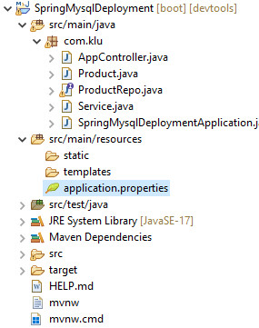

**AppController.java**

import java.util.List;

import org.springframework.beans.factory.annotation.Autowired;

import org.springframework.web.bind.annotation.CrossOrigin;

import org.springframework.web.bind.annotation.GetMapping;

import org.springframework.web.bind.annotation.RestController;

@RestController

@CrossOrigin

public class AppController {

@Autowired

Service s;

//http://localhost:8080/product

@GetMapping("/product")

public List<Product> retrieveProduct()

{

return s.retrieveData();

}

}

**Product.java**

import jakarta.persistence.Entity;

import jakarta.persistence.Id;

@Entity

public class Product {

@Id

int id;

String name;

public int getId() {

return id;

}

public void setId(int id) {

this.id = id;

}

public String getName() {

return name;

}

public void setName(String name) {

this.name = name;

}

@Override

public String toString() {

return "Product [id=" + id + ", name=" + name + "]";

}

}

**ProductRepo.java**

import org.springframework.data.jpa.repository.JpaRepository;

import com.klu.Product;

public interface ProductRepo extends JpaRepository<Product, Integer>{

}

**Service.java**

import java.util.List;

import org.springframework.beans.factory.annotation.Autowired;

@org.springframework.stereotype.Service

public class Service {

@Autowired

ProductRepo repo1;

public List<Product> retrieveData()

{

return repo1.findAll();

}

}

**Application.properties**

server.port=9000

#MYSQL CONFIGURATION

spring.datasource.driver-class-name=com.mysql.cj.jdbc.Driver

spring.datasource.url=jdbc:mysql://localhost:3306/fsad

spring.datasource.username=root

spring.datasource.password=root

#JPA HIBERNATE CONFIGURATION

spring.jpa.hibernate.ddl-auto=update

spring.jpa.properties.hibernate.dileact=org.hibernate.dialect.MYSQLDileact

spring.jpa.show-sql=true

**----------------------------------------------------**

**Run the springboot project.**

**Open MySql, and verify product table will be created automatically with empty records.**

**Add 3 records manually by executing following commands in mysql.**

**Sql> use jfsd;**

**Sql> Insert INSERT INTO product (id, name) VALUES (1, 'Laptop'), (2, 'Smartphone'), (3, 'Headphones');**

**Verify output in the browser:**

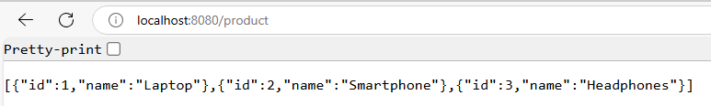

**Login into Railway.com**

**Click on Deploy New Project -> Deploy Mysql -> Data -> Connect -> Public Network**

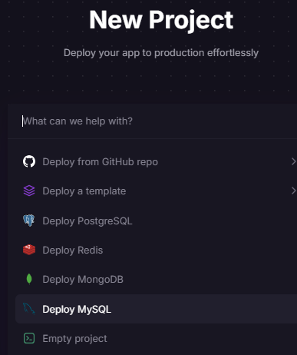

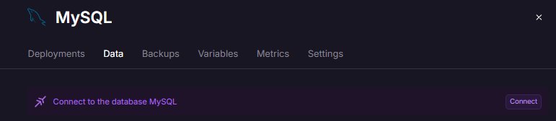

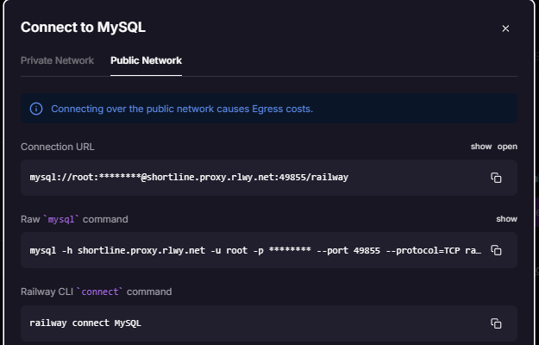

**Open Mysql Home Page and Click on the Plus sign**

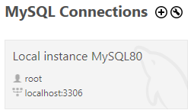

**Enter connection Name: Railway Host Provider, and fill the other details (Port number, database name, username, password) by copy from the Railway(Public Network screen)**

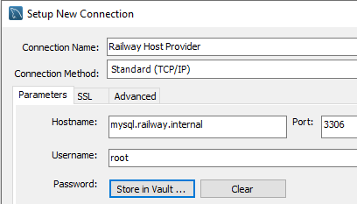

**Then Click on “Test Connection” Button.**

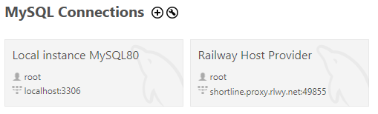

**Now we need to copy the above data into springboot project (application.properties)**

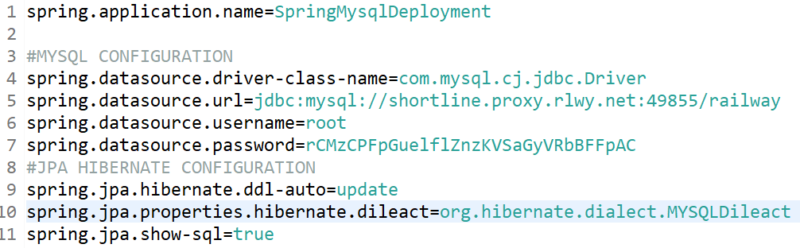

**Now save and run the springboot project. Verify “product” table is created in the “railway” database.**

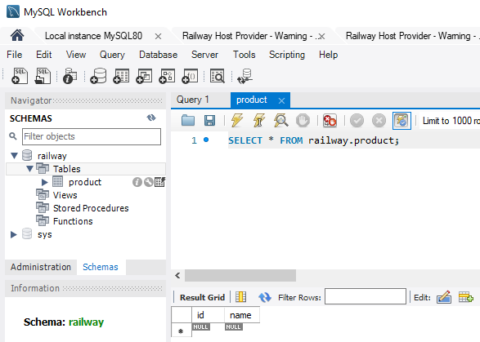

**Add 3 records manually by executing following commands in Railway mysql connection.**

**Sql> use railway;**

**Sql> Insert INSERT INTO product (id, name) VALUES (1, 'Laptop'), (2, 'Smartphone'), (3, 'Headphones');**

**Create a jar file in the target folder by executing: $mvn clean package**

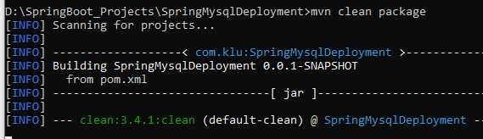

**With this command .jar file automatically added to the target folder in the spring project.**

**Push this Springboot project to the Github**

**Create a New Repository in the github with the name “SpringMysqlDeployment”**



**Execute the following commands to push into the Github from the directory where springboot project is available.**

**Git init**

**Git add .**

**Git commit –m “ok”**

**Git remote add origin https://github.com/lakshminarayana-kodavali/SpringMysqlDeployment.git**

**Git push –u origin master**

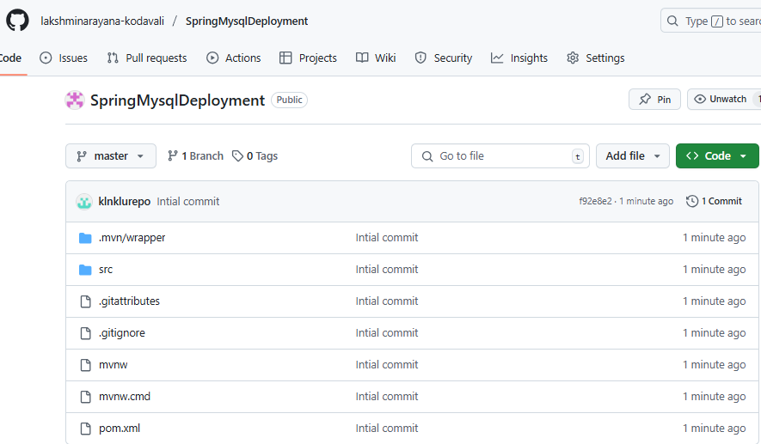

**Login into RailwayApp ( <https://railway.com/> ) and SignIn**

**Click on the “New Project” and choose “Deploy from GitHub repo” (first option)**

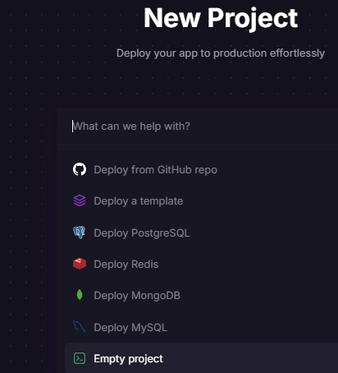

### ****Connect to GitHub Repository****

* Select your Spring Boot repository.

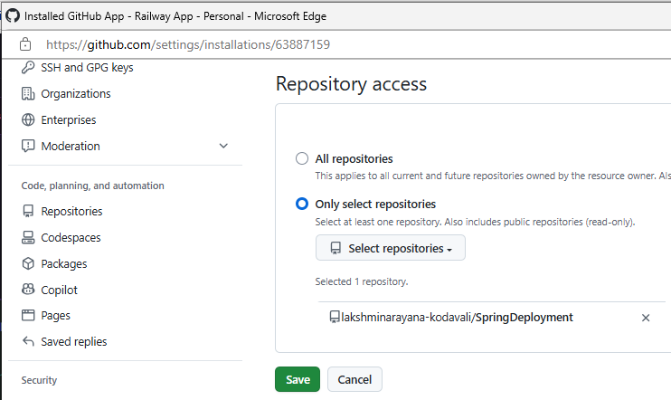

## **Deploy & Test:** Click **Deploy** and wait for the build to complete (It will take 2 minuits).

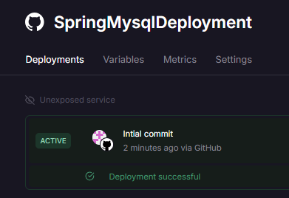

**We can get Railway URL from the Settings -> Networking -> Generate Domain**

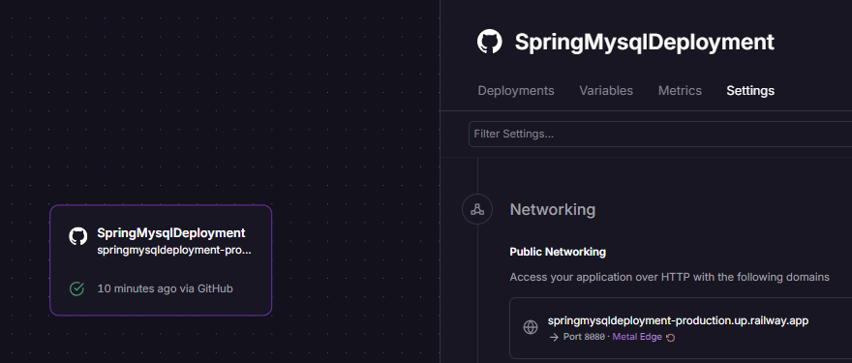

**Run this deployed project from the browser using Railway URL**

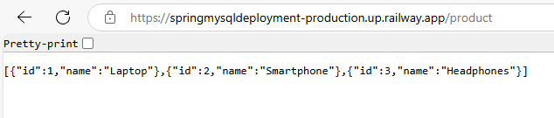

[**https://springmysqldeployment-production.up.railway.app**](https://springmysqldeployment-production.up.railway.app)

**springmysqldeployment-production.up.railway.app**